Compiled by:

Bryan ‘Bern’ Schotanes
mukian13@gmail.com
(813) 468 - 8354

Ari Bodaghee
abodaghee@gmail.com
(949) 878 - 0602

Daniel Lima
danielmarquesdelima@gmail.com
(407) 722 - 0404

Phillip Sullivan
psull48@gmaill.com
(937) 475 - 0946

Last updated: 2-8-12

Trinity
Table of Contents

Genre:
Platform:
Minimum System Requirements:
Target Audience:
Key Features:
User Experience:
Goal:
Game modes:
Controls:
Cameras:
Interface:
Main Game Menu:
In Game Menu:
HUD:
Other Game Menus:
Art and Production Design
Style of Art and Animation:
Style of Audio Effects:
Style of Music:
Treatment
Dust Jacket Description:
Expanded Description:
Characters
Playable characters:
The Player
Interactive non player characters:
Grandfather
Non interactive non playable characters:
Town Persons
World
Brief Description:
Visual Design:
Back Story:
Key Locations:
Rules:
Behaviors:
Environmental Aspects:
Initial world layout:
Game events
Game progressions milestones:
Walkthrough:
Items
Weapon Concepts:
Game screens layout
Influences and references
World visual influences:
Character influences:
Item influences:
Trick or Threat Beat - Cartoon Network game.
Technical Document
File Formats
Asset Dependencies
Pre-existing technology

Executive Summary

High Concept:

- Explore a large world, battle strange monsters, collect powerful weapons and items, and triumph over evil.

Genre:

- 3/4 Top-down fantasy adventure puzzle
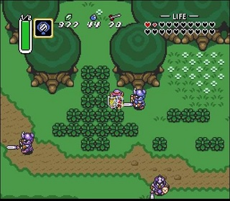

Platform:

- Windows 9X/NT/XP/Vista/7
- Arcade Machine

Minimum System Requirements:

- OS: Windows XP/Vista/7

- CPU: 2.40 GHZ or Above

- Memory: 512MB RAM XP / 1.5GB Vista/7

- Disc Drive: 1x speed

- Hard Drive: 200MB

- Video: NVIDIA GeForce4 MX4000 w/ 128MB with Pixel Shader 1.0 or equiv

- Sound: DirectX 9.0c compatiable

- Direct X: DirectX 9.0c

Target Audience:

- Primary: Hardcore gamers who like old-style fantasy RPG’s and puzzle games.

- Secondary: Casual gamers who would enjoy a game with adventure.

Key Features:

- Lots of enemies to defeat, using normal or special charged attacks.

- Many puzzles to solve on your journey.

- Three unique elemental weapons to collect.

- Large world to explore.

- Unique passive abilities acquired by masks.

User Experience:

- Player can move in four directions (from a top-down view) and explore a large world.

- Player eventually collects a total of three elemental-based weapons.

- Player has elemental attacks based on what weapon he has equipped.

- Player can attack enemies with his basic elemental attacks, or special charged attacks.

- Player can interact with certain things in the environment with his different elemental attacks.

- Player can collect small pick-ups (such as health) from slain enemies.

Goal:

- The goal of this game, for the player, is to find the three elemental weapons (detailed in the Items section), and obtain the ultimate power to defeat the evil entity that is corrupting the world.

- Scattered in the world are obstacles that, at first, cannot be surpassed. There is thick foliage that you can only break with the Fire Blade, there are rocks blocking your path which can only be broken with the Earth Hammer, and there are things (such as switches) that you can only reach with the ranged attacks of the Wind Shot.

Interactivity

Game modes:

Classic Adventure Mode

Controls:

- Keyboard:

  - Escape: Pause
  - W: Move Player Up
  - A: Move Player Left
  - S: Move Player Down
  - D: Move Player Right
  - Q: Swap weapon
  - E: Swap mask
  - Tab: Inventory
  - Enter: Attack (hold down to charge special attack)

- Controller:

  - Start Button: Pause
  - Left Stick: Move
  - Left Bumper: Swap weapon
  - Right Bumper: Swap mask
  - Y Button: Inventory
  - Right Trigger: Attack (hold down to charge special attack)

- Arcade

  - Joystick: Move
  - Top L Button: Cycle Weapon
  - Top M Button: Cycle Mask
  - Top R Button: Cycle Item
  - Bot L Button: Attack + Examine
  - Bot M Button: Inventory
  - Bot R Button: Pause

Cameras:

Top-down camera that follows the player as he walks through the world. The Camera will (TBD) only show 20x20 tiles at any given time. The Camera is always locked to the position of the Player’s position. The Camera’s Y position will be (TBD) 15 Units above the player. If the character is near one of the edges of the map, the camera stops so that it doesn’t goes off the screen. There will be times when the player will kill an opponent and trigger a Death Animation. At these Random times, the Camera’s Y position will drop and zoom on the player for a few seconds and then return back to it’s original state.

Interface:

Main Game Menu:

MAIN MENU:
New Game
  - Player will be able to select this option and it will immediately switch over to a Loading State. From there there, the game should be able to load all pre-made assets and Level information. The user can now start enjoying the game.
Load Game
  - When the player selects this option, he/she can boot from a previously saved file. There will only be 3 items to choose from in a top to bottom descending order starting from 1 to 3. When the player has finished selecting his save path, he will then go into the game from where he left off. The pause menu will automatically activate and the player must press “Un-Pause” to continue where he/she left off.
Tutorial
  - When the player chooses the Tutorial Menu, a Tutorial State Machine gets called and brings the player to a Simple Menu showing a brief graphic representing what buttons do what. There will be another graphic after the player clicks “continue” showing the main character moving and swiping at an enemy. This simple menu will represent the Tutorials for the entire game. There will be pop-up tutorials to further explain game mechanics when the player reaches those milestones.

Options
  - See Image Below:
Credits
  - The Credits menu will start off by showcasing the groups name. A list of game developers will begin scrolling across the screen starting from the bottom and working its way up. Afterwards, all the assets and creation tools will be featured. Finally, all important person’s will be honorably mentioned or acknowledged. When every single person and asset is shown, MainMenuState will be called and return the player to the Main Menu. Graphics and design are still TBD.
Exit
  - This will Exit the software and return to the Users Main Desktop Screen.

OPTIONS MENU:

- Video Settings:

  - The first adjustment that the player can tweak is FULLSCREEN Toggle “ON/OFF.” This allows the player to make a nice switch to a maximum screen size and get more real estate out of the game. If the player wishes to toggle FULLSCREEN off, he/she can potentially see a sharper image that better suits the resouution of the game source code. Default is ON.
  - The next adjustment that the player can tweak is a HUD Toggle “ON/OFF” switch. This will allow the player to view every possible section of GamePlayState without having to glance over at the health bar,ex. bar, and mini map cluttering the game. If the player wishes to have it left on, then he/she can have access to vital information regarding the player’s current state, weapon choice, mask, health, global position, and exp. Default is ON.
  - The Final adjustment would allow the player to determine where the MiniMap is displayed on the screen. The player will cycle through a tiny list of 3 quadrants. Up-right, Bottom-right, Bottom-Left. This will all the player to easily adjust to his/her preferences. DEFAULT is BOTTOM-RIGHT.

- Audio Settings:

  - The first adjustment that the player can tweak is BGM. You can go scroll the numbers from left to right This allows the player to listen to ingame music at low or high settings. Default is 100.
  - The last adjustment that the player can tweak is SFX. You can go scroll the numbers from left to right This allows the player to listen to ingame sound effects at low or high settings. Default is 100.
  - Controls
    - The Controls Menu State will feature a Graphic (TBD) representing the entire list of controls the player can use to manipulate the character and game. It may (TBD) list every input that could actually be changed to better personalize the controls for the user.

- Back
  - This will revert back to the MainMenuState and return to the User Main Screen.
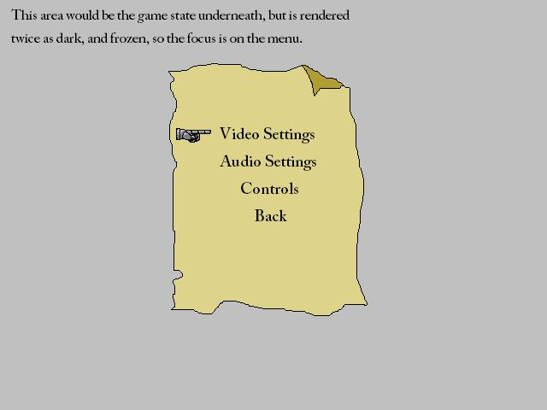

- VIDEO SETTINGS MENU:
  - (Video Settings)
  - Set Defaults
  - Back

- AUDIO SETTINGS MENU:
  - (Audio Settings)
  - Set Defaults
  - Back

- CONTROLS MENU:
  - (Controls Settings)
  - Set Defaults
  - Back

In Game Menu:

    - Save Game
    - Load Game
    - Options
    - Exit to Main Menu
    - Continue

HUD:

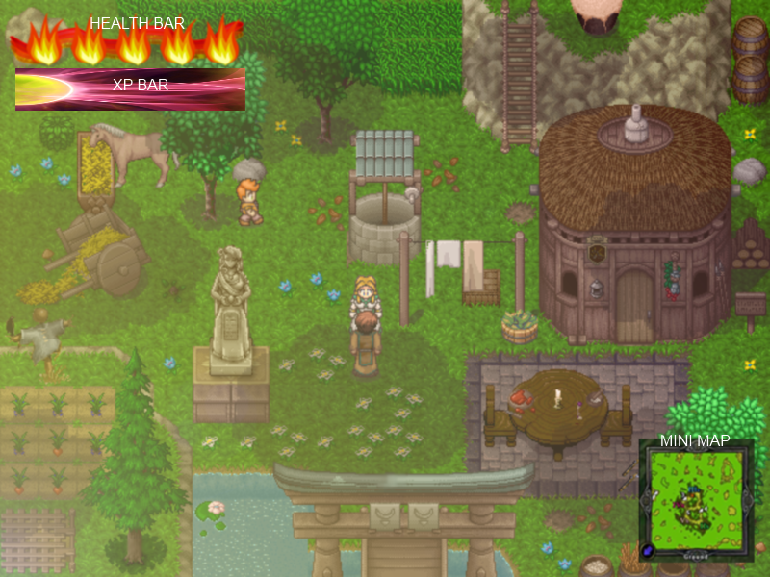
~Top left corner, there is a bar of graphical hearts to display the player’s health.
They will be 1 quarter the size of a World Unit. They will displayed in quick succession starting from left and continuing right.
~Top left corner underneath the Hearts, there will be a graphical representation of an EXP. Gauge. This gauge will continue to increase. When it fills up (gauge becomes full); automatically levels up your current weapon and returns back to 0.
~There is a Mini Map at any corner of your choosing.
The world map will have a Border of the color of your current weapon. The world map will display the entire world with your character pixel positioned according to where you are on the World Map Sheet. The character position will update every frame. The location of the world map may be positioned at the bottom right/left or top right/left. You can choose the position in the Main Menu State or the GamePlay Menu State.

These Hearts, EXP Gauge, and World Map take any form depending on the current weapon equipped by the player. Here are the Examples:

Ryza, Fire Blade: The HUD will take the form of Fire.

  - Health Containers will turn into red circles. A Particle System will emit red, yellow, and orange vertices's in the -y direction from each Health Container Position. This will give the effect of Fire, letting the player know visually, (besides what the player is holding in his hand), what type of item he/she currently has equipped. The next HUD object to be affected by the change of weapon is an EXP Gauge.
  - The EXP Gauge will appear under the health containers and will increase in alpha in based on how close the player is to their current level. After leveling it will be set to its base opacity. This bar will look like the image below with the fireball on the left side and colored to match the particle system.
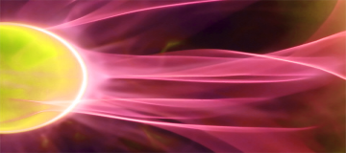

Krohmos, Earth Hammer: The HUD will take the form of Earth.

  - Health Containers will turn into Green mossy circles. A Particle System will emit green, white, and brown vertices's in the -y direction from each Health Container Position. This will give the effect of a sandstorm, letting the player know visually, (besides what the player is holding in his hand), what type of item he/she currently has equipped. The next HUD object to be affected by the change of weapon is an EXP Gauge.
  - The EXP Gauge will appear under the health containers and will increase in alpha in based on how close the player is to their current level. After leveling it will be set to its base opacity. This bar will look like the image below with the fireball on the left side and colored to match the particle system.
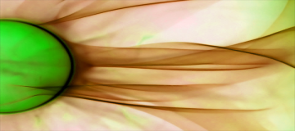

Ani, Wind Shot: The HUD will take the form of Air.

  - Health Containers will turn into red circles. A Particle System will emit blue, white, and purple vertices's in the -y direction from each Health Container Position. This will give the effect of a tornado, letting the player know visually, (besides what the player is holding in his hand), what type of item he/she currently has equipped. The next HUD object to be affected by the change of weapon is an EXP Gauge.
  - The EXP Gauge will appear under the health containers and will increase in alpha in based on how close the player is to their current level. After leveling it will be set to its base opacity. This bar will look like the image below with the fireball on the left side and colored to match the particle system.
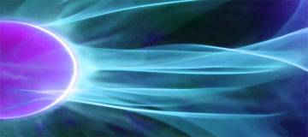

Other Game Menus:

Death menu:
You have been slain! Continue?
  - Yes (Go to Load Game)
  - No (Go to Main Menu)

Conversation Menu:
<Stuff Npc Says>
  - Enter/A to continue

Store Menu:
  - Buy
    - <item>
      - Are you Sure you want to buy?
        - Yes
        - No
      - Exit
  - Sell
    - <item>
      - Are you Sure you want to Sell?
        - Yes
        - No
      - Exit
  - Exit

Art and Production Design

Style of Art and Animation:

The art and animations are all in 2D, hand-drawn graphics. The game plays as if it is completely top-down, but the view has a slight angle, so the depth and detail of players and objects will be visible. Basically, when the player is facing down, we will not just see the top of the player’s head. We will see his face, body, and feet because of the slight angle. All graphics will also be affected by lighting.

Style of Audio Effects:

High-quality sounds; that of an action-fantasy genre.

All player actions will have a sound effect.

Style of Music:

High-quality music; that of an action-fantasy genre.

All areas will have a unique music.

The music may change depending on the theme of the area.

Treatment

Dust Jacket Description:

The player must go on a quest to find the three lost elemental weapons, to use their combined power to rid the world of evil.

Expanded Description:

A young woman died bearing a child. Before she died, she named the boy Rann.

Rann’s father detested him his entire life. It is unclear if this is why Rann was as evil as he was, or if it was simply inborn. As a child, Rann played cruel tricks on other children. As a young man, it was said that Rann began playing with black magic... One night, Rann murdered a boy named Javin, in an attempt to perform a dark ritual. For this, he was banished from his hometown and never allowed to return.

Rann was a madman. He could not understand why the others would not embrace his desire to unlock evil powers. He vowed to grow powerful and unleash havoc on the world and the town.

One night, an ominous storm swept across the land, and the village elder, Grimir, knew what this meant. Rann had succeeded in invoking Chaos, the endless. Grimir had never before revealed his powers, but knew what he had to do. It is impossible for one mortal to vanquish Chaos. However, with all of his strength, he shielded the town with a protective barrier, to keep the Chaos at bay.

You, Grimir’s granddaughter, awake in the middle of the night, because Grimir instructed you to in your dream. You wake up, and see the image of your grandfather standing in front of you. The image tells you to follow him, exiting the house and into the semi-wilderness near the town, to the old windmill.

In the windmill, you find Grimir himself, knelt down, trembling, and clutching a glowing sword. He tells you, with his dying words, to take this magic sword from him. He explains that the sword is embodied with one of the three Creators of Light; Ryza, of Fire. With it, you will be able to discover the remaining two Creators of Light; Krohmos, of Earth, and Ani, of Wind. When the three Creators are combined, only then will you be able to unlock the power to vanquish Chaos.

With his last ounce of strength, Grimir hands you the Ryza, and as his journey comes to an end, yours is only beginning.

Characters

Playable characters:

The Player
- Name: The Player
- One-Sentence Description: A young female warrior named <name> who acquires the fire elemental sword.
- Brief Description: Main character. A young female (20-21 yrs) commoner who loves adventuring and fighting. She has red hair, with a white headband, with long bangs curling around it, and a long ponytail. She has an egg white tunic/vest, which does not have sleeves, so her arm skin is visible. She is tan but not ridiculously tan. Her tunic goes down to her waist. She has a light brown sash that wraps around the tunic, above her waist. She has desaturated red pants that resemble capris (tight pants that just go down past her knees). The pants color, is desaturated red, but is somewhat lighter than her hair color. She has light brown shoes, with not much detail, just normal brown shoes that would fit the fantasy/adventure setting.
- Back-story: The players Grandfather uses magic to call out to the player character, beckoning them to follow through the very beginning of the game. The player received the fire sword here.
- Visual Design: Main character. A young female (20-21 yrs) commoner who loves adventuring and fighting. She has red hair, with a white headband, with long bangs curling around it, and a long ponytail. She has an egg white tunic/vest, which does not have sleeves, so her arm skin is visible. She is tan but not ridiculously tan. Her tunic goes down to her waist. She has a light brown sash that wraps around the tunic, above her waist. She has desaturated red pants that resemble capris (tight pants that just go down past her knees). The pants color, is desaturated red, but is somewhat lighter than her hair color. She has light brown shoes, with not much detail, just normal brown shoes that would fit the fantasy/adventure setting.
- Visual Attributes
  - Gender: Female
  - Height: 5’8”
  - Age: 20
  - Hair color: Red
  - Hair style: Ponytail with bangs going over headband
  - Eye color: Black
  - Ethnicity: White
  - Skin tone: Moderately tan
  - Clothing: Commoner/adventurer (detailed above in visual design)
- Game Play Attributes
- Weapon of choice: Fire elemental sword
- Abilities: Normal attack, and charge attack
- Game mechanics: Moving and attacking, collecting pick-ups
- Design influences: Zelda: Link to the Past
- Vocabulary of motion: Idle, walking, running, attacking, charging up, releasing for special attack, getting hit, dying
- Effects necessary for character: Sounds, animations, particle effects

Interactive non player characters:

Grandfather
- Name: Grimir
- One-Sentence Description: The players grandfather that starts your quest
- Brief Description: He is the elder of the town.
- Back-story:
- Visual Design: Long gray hair, gray beard. Wears a green robe. Desaturated reddish brown shoes (not really visible, because of the robe).
- Visual Attributes
  - Gender: Male
  - Height: 5’7”
  - Age: 56
  - Hair color: Gray
  - Hair style: Long
  - Eye color: Blue
  - Ethnicity: White
  - Skin tone: Pale
  - Clothing: Elders Robe
- Game Play Attributes
- Design influences: Legend of Zelda
- Vocabulary of motion: Standing, knelt down(near death), dying/dead.
- Effects necessary for character: Sounds, Animations’

Blacksmith
- Name: Blacksmith
- One-Sentence Description: The blacksmith is the person you go to to spend your jewels to upgrade weapons.
- Brief Description: He is a blacksmith, secluded from the town.
- Back-story: Crazy hermit-type man who lives alone but is old and wise and knows about the elements and is able to upgrade your weapons, for a price.
- Visual Design: An old, but strong, blacksmith.
- Visual Attributes
  - Gender: Male
  - Height: 5’5”
  - Age: ??? Oldest person in the world
  - Hair color: White
  - Hair style: Long
  - Eye color: Black
  - Ethnicity: White
  - Skin tone: Burnt brown
  - Clothing: Blacksmith gear
- Game Play Attributes
- Design influences: Legend of Zelda
- Vocabulary of motion: Standing idle (breathing), walking
- Effects necessary for character:
  - Sounds- Smacking hammer against anvil
  - Animations- Smacking hammer against anvil/standing

Shopkeeper
- Name: Shopkeeper
- One-Sentence Description: The Shopkeeper is the person you go to, to buy potions.
- Brief Description: He is the owner of the potion shop.
- Back-story: None
- Visual Design: A young woman.
- Visual Attributes
  - Gender: Female
  - Height: 5’9”
  - Age: 27
  - Hair color: Blonde
  - Hair style: Long
  - Eye color: Blue
  - Ethnicity: White
  - Skin tone: Peach
  - Clothing: A summer dress.
- Game Play Attributes
- Design influences: Legend of Zelda
- Vocabulary of motion: Standing (breathing)
- Effects necessary for character: Sounds, Animations

Town Persons
- Name: Town Person
- Brief Description: A person in the town
- Visual Design: varies
- Visual Attributes
  - Gender: varies
  - Height: varies
  - Age: varies
  - Hair color: varies
  - Hair style: varies
  - Eye color: varies
  - Ethnicity: varies
  - Skin tone: varies
  - Clothing: varies
- Vocabulary of motion: Animation, Sounds
- Effects necessary for character

World

Brief Description:

A massive map containing many different ecosystems including forests, caves, deserts, and plains. The entire map will be loaded into memory upon boot up

Visual Design:

- Day/Night based light
- Natural objects
  - Breakable foliage
  - Trees
  - Rocks
  - Fences
  - Houses
  - Cliff walls
- Possibly weather.

Back Story:

Times were peaceful in the land of Valest.
People built towns, hunted game, and told stories by the fire.
One story told of three elemental weapons, hidden across the land.
Another told of a sorceror named Rann, who worshipped Chaos, the endless.
One day, a strange storm swept over the land.
The legend of Rann was no story, and he had finally unleashed Chaos on Valest.
Powerful monsters roamed free...
If the legend of the weapons were also true, perhaps we could be saved...

<To title screen>

In the very long lost past, three gods with different powers used their skills to create this world. First, the Fire God created a big massive ball of hot magma to be the world’s core. Then, the Earth God covered that with land and vegetation. Finally, the Air God cooled the planet and modeled its mountains and plains. With the world created, the gods used their powers all together to create different species of living beings. After some millenniums, they were tired of living without any challenge or emotion, so they decided to transfer their souls to human bodies. To do that, the gods stored their powers in three magic weapons, thus creating the Magma Blade, the Wind crossbow and the Rock Hammer, and hid them throughout the world. They knew that if anything threatened them those weapons would be available for them to get their powers back.

Random idea because I can’t sleep:

Part of the story could be that when Chaos was released, the three Light elements (fire, earth, wind) were like, suppressed.

So like NPCs could talk about that. Once the dark cloud thing swept over, that the sun isn’t quite as warm anymore (Creator of Fire suppressed). Crops quickly start to die, like the soil itself is dying (Creator of Earth suppressed). Wind also stopped, which explains why the boats can’t move, and an old windmill right at the front of your hometown can’t move either (Creator of Wind suppressed).

So, as per Daniel’s idea with returning to the home town for some super-late part in the game, you go back home after getting the wind bow and turn on the wind mill... It could be mentioned somewhere that Grimir (the grandfather that died in the beginning) really liked the windmill and always went inside it at night. When you turn it back on, an NPC comes and says, Wow look at that, the windmill is running again, blah blah, and he talks to you about Grimir and how he loved that windmill, and says that Grimir gave him a weird key, and that he was told to give it to you if you started the windmill. You go in, and it’s just an empty circular room with straw on the floor and stuff, but when you walk in when you have all three weapons, some cool particle effect happens and a door appears on the wall, which you use the key on. Inside there it’s basically like a secret study, with bookshelves, scrolls, decoration potions, and notes on Light magic and stuff, and in there you find the <whatever> that combines the three elements and releases their power, so you can have access to the last area and fight the boss, wherever that is.

Just an idea. It would require enter-able houses so that kinda sucks.

Key Locations:

Standard features per area type.

- Plains
- Caves
- Forests
- Deserts
- Towns
- Dungeons
  - are also part of the world map, but are darker and indoors.

Rules:

- Find the three elemental weapons and defeat the last obstacle of the world.

Behaviors:

- Time of day changing.
- Possibly weather.

Static Terrain:

- Different types of ground
  - Grass
  - Flowers
  - Dirt
  - Sand
  - Transition blocks (such as grass fading into dirt)
  - Road
  - Water
  - Gravel
  - Snow

- Collidable vegetation
  - Trees.
  - Shrubs
  - Cactus
  - Plants

Dynamic Terrain (interactive):

- Ryza, the Fire Blade
  - Bushes
    - player can cut them using the sword.
  - Snow
    - player can melt using fire power.
  - Ice
    - player can melt using fire power.

- Krohmos, the Earth Hammer
  - Rocks
    - player can smash them using the hammer.

- Ani, the Wind Shot
  - Boxes
    - player can move them using wind power.
  - Barrels
    - player can move them using wind power.

- Base Character
  - Chests
    - player can open by pressing an action key.
  - Doors
    - player can open by pressing an action key.
  - Handles
    - player can open by pressing an action key.
  - Switches
    - player can open by pressing an action key.
  - Buttons
    - player can activate by pressing an action key.

Environmental Aspects:

  - Rain
  - Wind storms

Initial world layout:

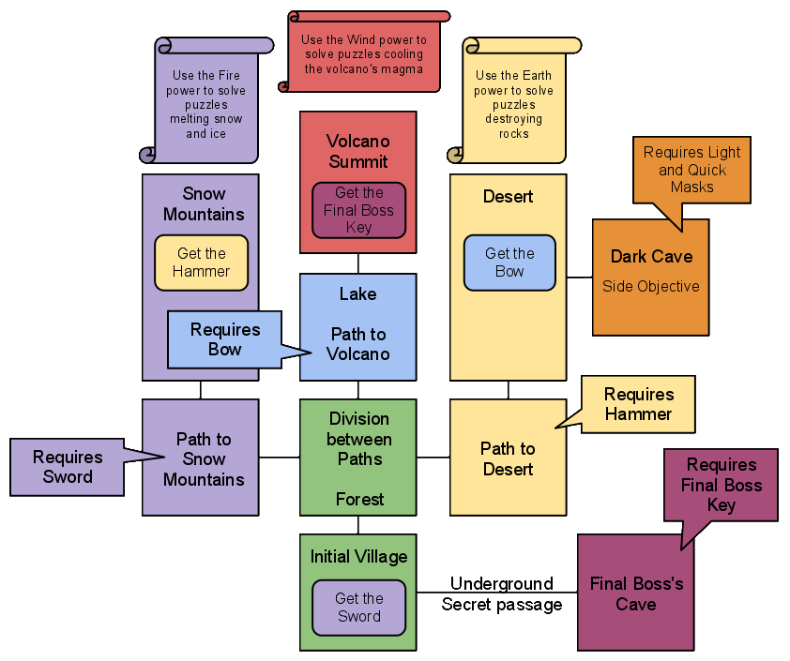

Game events

Game progressions milestones:

- Win Condition: Defeat the final boss. When you reach this condition, your character will play a victory animation and will be placed at the Victory screen after 3 seconds.

- Lose Condition: Take enough damage to lose all of your hearts. When you reach this condition, Your character will play a die animation and after three seconds you will be returned to the Load Game Screen.
  - Ways to take damage:
    - Suffer a basic attack from a regular enemy (loose one heart).
    - Suffer a special attack from a boss (loose one or more hearts).
    - Touch on fire or something (loose one heart).

Walkthrough:

- Start the game in the Main Village. This works as an intro level in which the player will learn how to move and use his basic attacks.

- Explore the village if you want to. There will be some NPCs around and a Shop.

- Talk to the Village’s Elder (he’ll be at the geographic end of the level), who happens to be your Grandfather. He’ll give you the Ryza Blade, which has the power of Fire, teach you how to use it and introduce you to your mission.

- Once you’re done exploring this map, walk North (the only way you can actually go) to leave the village.

- You’ll find yourself on a small forest with some monsters. At North, there will be a lake blocking your passage with a boat and a fisherman in it. At East, trees and rocks will be blocking your passage. Go West and you’ll find a clear path to a new area.
- You will keep walking through a forest until some trees appear to have snow on their leaves. Go North and you’ll start climbing a mountain (just normal movement).

- As you get higher, the mountain will be more and more filled with snow until you actually reach (PUT TOWN NAME HERE), a village spread through a chain of mountains covered in snow.

- You will need to kill a couple monsters and solve puzzles using your fire sword to melt snow, ice and other frozen stuff.

- After a while, you’ll find a Hammer that has been stuck in the ground for centuries. Nobody could ever get it out of there. Melt the ground and the Krohmos Hammer, which has the power of Earth, will be yours.

- Hang around the snow mountains if you want but go back to the Forest if you want to progress through the game.

- Go East this time and use your hammer to open the path.

- After walking a little bit, maybe finding some chests if you’re a good explorer and definitely killing a couple monsters, you’ll find a large, dry and rocky desert.

- In the desert, you’ll solve puzzles using the Ryze Blade and Khromos Hammer - basically smashing rocks and burning things. There will also be quicksand that will make you sink unless if you’re wearing the Quick Mask.

- After a while you’ll find a valley that has wind blowing through it, towards you. Use your hammer to pound a wall, making rocks fall and stop the wind, clearing your way. Walk through this path to find the Ani Crossbow, which has the power of Wind.

- Go back to the Forest, where the paths are divided. Find the fisherman and hop into his boat. Now that you have the Crossbow, you can use it to trow waves of wind in any direction you’re facing. Use this skill to blow the boat through the lake.

- Get to the other side of the lake and discover the Volcano’s Summit. In this area, you’ll need to use all the weapons you’ve gotten so far to kill enemies and solve puzzles. When lava blocks your passage, for example, you’ll need to cool it using wind so that it becomes a rock that you can destroy with the Hammer.

- Enter in the volcano to find the amulet your grandfather sent you to look for.

- Go back to your village to find out that it was destroyed by the game’s Villain and that all the people disappeared. Place the amulet on the center of the town’s Main Statue and open the path to the Final Dungeon.

- In this place, you’ll need to find all residents of your village and free them from imprisonment. This will require you to use all your weapons.

- On the last room, when you’re about to save the Village’s Elder, your Grandpa, you’ll find the Final Boss. The Boss will have different states and will keep alternating between them. You’ll need to switch between weapons quickly so you can counter each one of his different attacks.

- Defeat the final boss, save the village and win the game!

Puzzle Elements:

- Switch / Door: Can be activated/opened by the player.
- Torch: Can be lit by the Fire Blade and unlit by the Wind Shot.
- Snow: Can be melted by the Fire Blade, becoming water and revealing the ground beneath it.
- Frozen Switch: Can be melted by the Fire Blade and used afterwards.
- Rock: Can be destroyed by the Earth Hammer and moved by the Wind Shot.
- Specific Walls: Can be pounded by the Earth Hammer and let rocks or other objects fall.
- Lava: Can be cooled and solidified by the Wind Shot and then destroyed by the Earth Hammer.
- Bush / Vegetation: Can be burned or cut by the Fire Sword.
- Windmill: Can be rotates by the Wind Shot.
- Sand: Can be blown away by the Wind Shot.
- Tough Switch: Can be activated by the Earth Hammer.
- Quicksand: Only the Quick Mask would allow the player to pass through it without sinking.
- Dark Area: Only the Light Mask would allow the player to light it.

Items

Weapon Concepts:

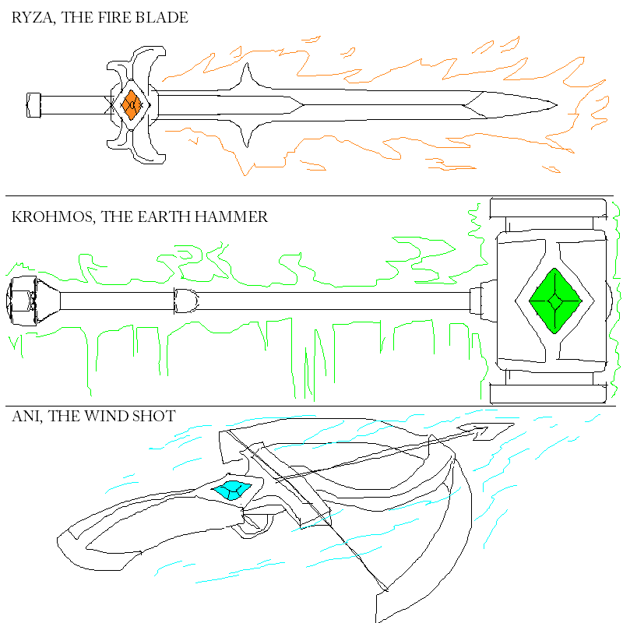
Weapon Animations:
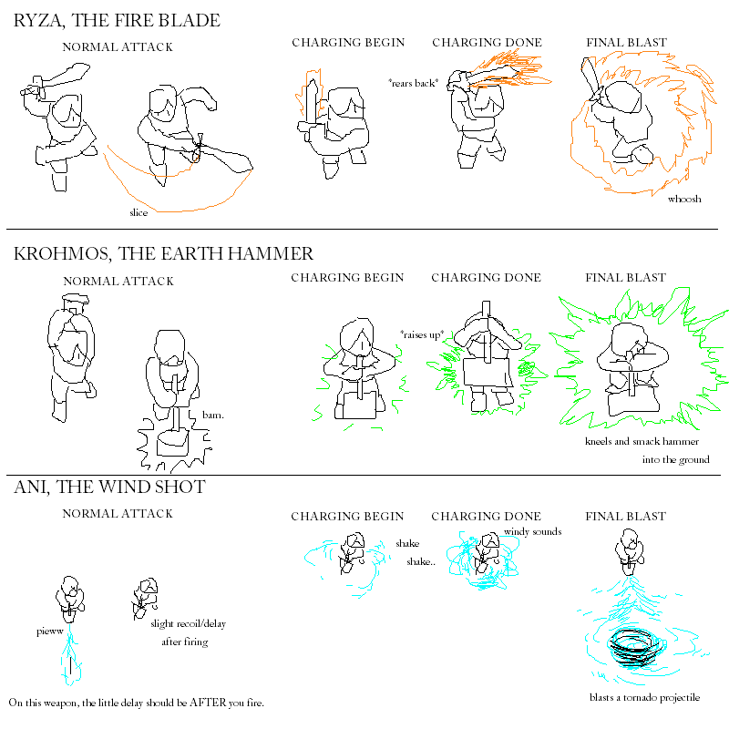

- Ryza, the Fire Blade

  - Basic Attack (Levels 1 through 3)
    - Damage : 8 .. 12 .. 16
    - Dmg. Explain : (base value: 4 dmg … L1 = 4*2, L2 = 4*3, L3 = 4*4)
    - Action : Rears back with small delay, forward slash.
    - Interaction : Clears thicket.
  - Charged AOE Attack (Levels 2 and 3 only)
    - Damage : 16 .. 24
    - Dmg.Explain : (base value: 8 dmg … L2 = 8*2, L3 = 8*3)
    - Action : Spins in a fiery whirl, burning nearby foes.
    - Interaction : Clears thicket. Clears ice/frozen objects.
  - How to obtain it: The player has to finish the first part of the intro level / tutorial by completing basic actions like learning how to move and attack.

- Krohmos, the Earth Hammer

  - Basic Attack (Levels 1 through 3)
    - Damage : 14 .. 21 .. 28
    - Dmg. Explain : (base value: 7 dmg … L1 = 7*2, L2 = 7*3, L3 = 7*4)
    - Action : Rears back with bigger delay, overhead smash.
    - Interaction : Breaks small rocks.
  - Charged AOE Attack (Levels 2 and 3 only)
    - Damage : 6 .. 9
    - Dmg. Explain : (base value: 3 dmg … L2 = 3*2, L3 = 3*3)
    - Action : Hits hammer by feet, slightly hurting and stunning nearby foes.
    - Interaction : Breaks small rocks. Breaks bigger rocks.
  - How to obtain it: The player has to first have the Fire Blade, and then solve the area that requires it.

- Ani, the Wind Shot

  - Basic Attack (Levels 1 through 3)
    - Damage : 6 .. 9 .. 12
    - Dmg. Explain : (base value: 3 dmg … L1 = 3*2, L2 = 3*3, L3 = 3*4)
    - Action : Shoots a projectile in facing direction, tiny delay after firing.
    - Interaction : Can hit switches or enemies normally out of reach.
  - Charged AOE Attack (Levels 2 and 3 only)
    - Damage : 10 .. 15
    - Dmg. Explain : (base value: 5 dmg … L2 = 5*2, L3 = 5*3)
    - Action : Shoots a tornado, damaging and blasting away foes.
    - Interaction : Can solve some air puzzles, such as getting a boat to move.
  - How to obtain it: The player has to first have the Fire Blade and the Earth Hammer, and then solve the next area, which requires both weapons.

The Masks:

- Light Mask: The player emits golden light so they can see in dark places. Glows gold.

- Glow Mask: The player absorbs some damage that he takes. Glows orange.

- Quick Mask: The player moves 1.5x faster. Glows magenta.

- Blood Mask: The player drains health (50% of dmg dealt) from attacking. Glows red.

- Stealth Mask: The player is invisible to most monsters, until attacking. Glows white.

- Jump Mask: The player can leap across certain predetermined gaps. Glows royal blue.

Hearts:

- The player starts the game with 5 “hearts”, and every enemy attack deals damage equivalent to one or more hearts. 10 chests hidden around the world will contain one piece of heart each. If the player finds two pieces of heart, his character gets an extra heart-container, thus becoming more resistant to enemy hits. Since there are 10 half-hearts and the player already starts with 5, the max amount of health the player can have is 10 full hearts.

XP items:

- Small Jewel +1
- Jewel +5
- Big Jewel +20
- Grand Jewel +100

Game screens layout

Influences and references

World visual influences:

- Zelda: A Link to the Past.
- League of Legends.
- Odin Sphere.

Character influences:

- Link: Legend of Zelda.
- War: DarkSiders.

Item influences:

- Zelda: A Link to the Past.

Trick or Threat Beat - Cartoon Network game.

Technical Document

File Formats

- XML Tile Mapping

- XML Animation

<?xml version="1.0" encoding="utf-8"?>
<Animations>
<Animation name ="Name" islooping ="false" isoslating ="false" isplaying ="false" ImageID ="0">
<Frames>
<Frame objRectL ="0" objRectR ="0" objRectT ="0" objRectB ="0"
colRectL ="0" colRectR ="0" colRectT ="0" colRectB ="0"
anchorX ="0" anchorY ="0" duration="0.0" event ="string"/>
</Frames>
</Animation>
</Animations>

- XML Particle

- XML Save File

- PNG
- WAV
- MP3

Pre-existing technology

- Particle Effects Generator from Mr. Bodaghee

  - Overview:
  - Current tool only works in C++ and calls Texture Manager’s Draw from David Brown’s class. One emitter is used and Draws any texture of the programmers choosing. You can determine the:
<>Amount of Particles
<>Initial Position
<>Bounding boxes so the Particles never go past.
<>Amount of Starting and Ending Life.
<>Amount of Min and Max Velocity for Both X and Y.

The Particle Editor is not made to the specifications of the class or the project. Henceforth, it will not be used- and only referenced for when the Particle Editor gets made for C#.

- DirectX

  - Overview: the game will use a Direct3D wrapper class that will handle D3D initialization and will work with the camera system to render in multiple viewports. The wrapper will be able to draw inside a specified rectangle, allowing us to draw multiple items on the screen such as the radar or the overhead map. The class will also allow for cleaning up and releasing of all loaded D3D objects.

- SGD Wrappers

  - Overview:

- XAUDIO/FMOD

  - Overview:

Asset Dependencies
WORLD GROUND TILES (all world tiles are 32x32)
**This game is viewed from top-down perspective, like Link to the Past.**
**All ground tiles, then, should appear to be viewed from top-down.**
**However, just like Link to the Past, it’s not exactly straight down,**
**There is a slight angle. Therefore, all ground tiles should have a**
**very >subtle< squashed/horizontal effect.**
Grass Tiles:
  - Simple tiling grass textures.
  - Totals: Total of 6 plain grass tiles. The pattern of the grass should differ slightly with each tile, but still be seamless with the others. Do not include small pebbles, or distinctly visible flowers, etc, just make the natural grass patterns with very subtle details.
Grass Tiles w/ rocks:
  - Tiling grass with rocks.
  - Totals: Total of 6 grass tiles w/ rocks. Using the six different unique grass tiles, add some random pebbles and rocks.
Grass Tiles w/ flowers:
  - Tiling grass with flowers.
  - Totals: Total of 6 grass tiles w/ flowers. Using the original six different unique grass tiles, add some random flowers- some tiles are white flowers, some yellow, some light pink, and some light blue.
Grass Tiles w/ branch:
  - Tiling grass with branches
  - Totals: Total of 3 grass tiles with branches/twigs. Just a small group of tiles with a couple twigs/branches on three of the existing default grass tile textures.
Dirt Tiles:
  - Tiling dirt textures.
  - Totals: Total of 6 plain tiling dirt tiles. The pattern of the dirt should differ slightly with each tile, but still be seamless with the rest. Do not include pebbles or rocks, just make natural dirt patterns with subtle details.
Dirt Tiles w/ rocks:
  - Tiling dirt with rocks.
  - Totals: Total of 6 dirt tiles w/ rocks. Using the six unique dirt tiles, add some random pebbles and rocks, make sure the rocks are NOT big enough to seem like they would block the player.
Dirt Tiles w/ farmland:
  - Tiling farmed/tilled/plowed dirt
  - Totals: Total of 3 dirt tiles w/ a vertical ‘farmed/tilled land’ pattern. Basically, just a slightly jagged darker line cutting down through the middle of the textures, so it looks like the dirt was tilled to plant crops. Also need 2 extra textures for the tops and bottoms of those vertical tilled lines.
    - 3 random varied textures for the actual tilled land
    - and 2 tiles for the tops and bottoms of those tiles
Sand Tiles:
  - Tiling sand textures.
  - Totals: Total of 6 plain tiling sand tiles. The pattern of the sand should differ slightly with each tile, but still be seamless with the rest.
Snow Tiles:
  - Tiling snow textures.
  - Totals: Total of 6 plain tiling snow tiles. The pattern of the snow should differ slightly with each tile, but still be seamless with the rest.
Transition Tiles:
  - Dirt edge tiles.
  - Totals: All tiles needed to ‘automatically’ form a dirt path (uses the previous Dirt Tiles). So, there should be “transition tiles” from grass to dirt. Include corner transitions. This should total to 4 vertical transition textures (ex: Grass on left half, dirt on right half) and 8 corner textures. Imagine a wide dirt path in the shape of a thick plus sign “ + “ and it explains all 8 necessary corners.
    - Make a set for these for “dirt to grass”
    - Make a set for these for “dirt to snow”
    - Make a set for these for “snow to grass”
    - Make a set for these for “sand to grass”
Shoreline Tiles:
  - Shoreline
  - Totals: The tiles where the ground meets the water. For each set, again, like above, 12 total textures are needed for a proper complete transition set.
    - A set for “sand to water”
    - A set for “grass to water”
    - A set for “dirt to water”
Removed plant:
  - A thin plant used to be here.
  - Totals: In this tile, a weak plant (32x32) used to be there, but it was removed by the player. Should still be a base texture (just pick one of the random 6 as a base), but slightly darker in the center, with a little stem in the middle, and a few scattered leaves as remains.
    - One for grass tile base
    - One for dirt tile base
    - One for snow tile base
Removed thicket:
  - A dense thicket used to be here.
  - Totals: In this tile, a very dense foliage (32x32) used to be there, but it was burned through by the player. Should still be a base texture (just pick one of the random 6 as a base), but much darker, with a bigger stem in the middle, and lots of black scattered remains of the thicket, since it was burned.
    - One for grass tile base
    - One for dirt tile base
    - One for snow tile base
Removed rock:
  - A stone was here, but was smashed by the player
  - Totals: In this tile, a large stone, which was the size of the tile itself (32x32), was here (which blocked the player), but the player smashed it with an certain weapon he acquired later. The ground should be darker in the shape of a round stone below where it used to be. Need one for grass tile, dirt tile, and for snow tile.
    - On the grass tile, but most of the grass toward the center of where the rock was should be dirt instead, since a heavy rock sitting on the ground wouldn’t have grass growing under it.
    - On the dirt tile, but the dirt is darker underneath where the rock was, since it was heavy.
    - On the snow tile, show dirt under where it was, being darker in the middle.
Cobblestone Floor:
  - Dungeon floor tiles
  - Totals: We need six unique tiles for cobblestone floor. They should all tile seamlessly but please don’t make them actual square blocks. They should appear to be “random” shaped stones so the tiling effect isn’t that noticeable. Some could have slight grass mossy pixels on them - some a bit more or less than others to add to the randomness.
Stone floor pressure plate:
  - Stone pressure plate
  - Totals: Need 1 tile for a 32x32 tile of a stone pressure plate. The graphic should basically take up the whole tile. Should match the dungeon cobblestone texture in theme.
Ice tiles:
  - Ice tiles
  - Totals: Need 6 unique tiles for frozen water that the player can walk over. Also need 12 additional tiles for all the borders of the ice, where it transitions to water. Also need 12 additional tiles for all the borders of ice, where it transitions with snow.
    - 6 unique tiling ice tiles
    - 12 ‘transition tiles’ transitioning into water
    - 12 ‘transition tiles’ transition into snow
Wooden Floor:
  - Wooden floor tiles
  - Totals: We need 3 unique tiles for wooden floor. All the wood boards should be horizontal direction (on the screen). Should all tile seamlessly.
Fancy Rug Floor:
  - Fancy interior rug
  - Totals: Need all tiles requires to make a tile-based rug on an indoor floor. At minimum, this is 9 tiles: Each four corners, each four sides (top, left, bottom, right), and 1 for all the middle tiles. Could have 2 tiles for the middle tiles.
    - A desaturated red/brown rug.
    - A desaturated dark blue/white rug.
    - A desaturated green/brown rug.
Ceramic Floor Tiles:
  - Ceramic floor tiles
  - Totals: Need 3 unique tiles for reddish-brown ceramic indoor tiles, kitchen area. Should tile seamlessly.
Indoor carpet Tiles:
  - Indoor carpet tiles
  - Totals: Need 3 unique tiles for seamless tiling indoor generic carpet texture. No fancy designs on this, just plain carpet with a color and some noise/shading.
    - A beige carpet.
    - A brown carpet.

MOVEMENT-BLOCKING TILES (walls, rocks, signs) (all tiles are 32x32, but some larger objects, like bed, cabinets, may need multiple tiles to complete the object)
(MOST OF THESE TILES SHOULD BE MASKED, so we can see tiles potentially underneath them, except for the wall tiles, which take up the entire tiles.)
House Tiles:
  - Different house tiles.
  - Totals: We need enough tiles to construct different houses. Need both wooden wall textures, gray stone wall textures, and a tan material that looks like adobe, also for wall textures. Since the game is viewed from above, the wall tiles that appear to be vertical should fit “two” height units in one tile. So, for example, a block of 1x2 tiles on the ground should fit, visually, into just one vertical tile, since it’s vertical at a sharp angle. Also need window and door tiles (each only using 1 tile) for each material type (wood, stone, adobe). Also need dark brown and dark red (separate) roof tile textures, and tiles for stone chimneys sticking out of the roofs.
Sign Tile:
  - A masked sign texture.
  - Totals: This tile just takes 1 unit, and is a masked texture of a normal wooden signpost. It is always facing south so that the viewer of the game can "see" the written face of the sign.
Interior Decoration Tiles:
  - All interior decoration tiles.
  - Totals: All tiles necessary to make interiors of homes.
    - Table, counter, sink, potted plant, cupboards, couch, tall cupboard, fridge, chair, stool, oven, range, bed, pillow, mats, bookshelf, cup on table, bowl on table, flowers on table, potions on table, book on table, shelves with various items.
Rock:
  - A rock, outside
  - Totals: Three unique tiles for similar-looking rocks, using the entire 32x32 tile for each. One for sitting on grass, dirt, and snow. On the snow background, have some snow on top of the object.
Thin plant:
  - A weak plant
  - Totals: This small plant occupies one tile, it doesn’t look very thick, but it should look thick enough to block the player. (It can be destroyed by your default weapon). Need one for grass, dirt, snow, and sand. On the snow background, have some snow on top of the object.
Dense Thicket:
  - A dense foliage/plant
  - Totals: This plant is much thicker, you can’t see through the middle of it, and it blocks the player. It must be burned through with a special fire weapon. Need one with grass, dirt, and snow backgrounds. On the snow background, have some snow on top of the object.
Big Lever:
  - Big Lever.
  - Totals: A large stone lever, which takes up 1 tile, which blocks the player. It can be hit with any weapon to flip it on or off. Therefore, it must have two graphics: flipped left and flipped right.
Tree Tiles:
  - All tree tiles.
  - Totals: These should be all the tiles required to draw trees. This should include tiles to draw a single tree, alone, and an impassable line of trees, which look like the same tree but closer together. This may or may not require actually having tiles for the bottom of the tree trunks. Because, the tree should be vertical so the angle may not be enough to actually visibly show the tree trunks. The top of the tree should be 4 by 4 tiles (128x128), but they should still be individual 32^2 tiles.
    - Tiles to create a normal tree
    - Tiles to make a ‘tree line’ in any direction
    - Tiles to create a dead tree (without leaves)
    - Tiles to create a dead tree (without leaves) with snow on it.
Dock Tiles:
  - Wooden dock tiles
  - Totals: Tiles to draw a wooden bridge or wooden dock. There should be a tile for each edge, top left right bottom, two middle tiles (for a bridge going north/south, the boards are horizontal, and for a bridge going west/east, the boards are vertical). And edge tiles with poles extending into water. All these tiles are masked so we could potentially see tiles under it. So technically they should look fine if they are rendered over dirt or grass, for example.
Windmill:
  - Windmill tiles.
  - Totals: All tiles needed to render a windmill, with tiles. A lot of the windmill is already complete, with the house wall tiles. But it needs some tiles for toward the top of the structure. Additionally, there will need to be some masked tiles for the spinning blades. The blades should spin in only 4 frames of animation. Masked.
Misc. Town Objects:
  - Misc. town objects.
  - Totals: Tiles needed to display miscellaneous town objects. These will be masked textures. If they are a tall object, it may need two tiles total, since it may not fit vertically on one tile. Masked.
    - Brown barrel
    - Light brown crate
    - Reddish brown crate
    - Short crate filled with food
      - Fish
      - Potatoes
      - Green veggies
    - Basket of fruit
      - Apples
      - Oranges
Lamp Post:
  - Lamp post tiles
  - Totals: Tiles needed to render a lamp post. Should be twice the height of a door, therefore, requires two tiles total. Masked.
Treasure Chest:
  - Treasure chest.
  - Totals: Treasure chest, taking up one tile, reddish-brown with gold or silver trims.
    - Open and closed.
Fences:
  - Fences
  - Totals: Tiles needed to render fences. Should be masked. Needs a tile for fence going north/south, and one tile for west/east, and end post fence tiles for each possible direction (4), and the four possible corner fence tiles.

CHARACTERS:
Humans:
**All humans are drawn in 3x3 32^2 tiles, so, 9 tiles total, with the actual sprite being mostly in the center. The visible size of each human should be only slightly larger than 32x32, so the physical collision box of the humans can be 32x32. The arms and legs while walking might leave that 32x32 collision box, but that’s ok, that’s how it is in most of these games (like Link to the Past -- when walking thru a thin hall, his hat, sword, or feet might overlap the surrounding walls a bit, so that the visual player is slightly bigger than the hitbox.)**
**Additionally, humanoid characters will need to be rendered in two layers. A legs layer and then the rest. Both layers should still be 3by3 32x32 tiles, with the character in the center. The purpose of having the legs rendered separate is so the top torso half can be doing actions independent of the legs half.**
Main Character:
  - Young female character fighter.
  - Totals: Main character. A young female (20-21 yrs) commoner who loves adventuring and fighting. She has red hair, with a white headband, with long bangs curling around it, and a long ponytail. She has an egg white tunic/vest, which does not have sleeves, so her arm skin is visible. She is tan but not ridiculously tan. Her tunic goes down to her waist. She has a light brown sash that wraps around the tunic, above her waist. She has desaturated red pants that resemble capris (tight pants that just go down past her knees). The pants color, is desaturated red, but is somewhat lighter than her hair color. She has light brown shoes, with not much detail, just normal brown shoes that would fit the fantasy/adventure setting.
    - Standing, idle, breathing light. All four directions. 3 frames.
      - The torso section should be in these stances
        - As if holding a longsword (one-handed)
        - As if holding a battle hammer (two-handed)
        - As if holding a crossbow (two-handed)
    - Walking. All four directions. 5 frames
      - The torso section should be in these stances
        - As if holding a longsword (one-handed)
        - As if holding a battle hammer (two-handed)
        - As if holding a crossbow (two-handed)
    - Running. Ponytail should lift as running. 5 frames.
      - The torso section should be in these stances
        - As if holding a longsword (one-handed)
        - As if holding a battle hammer (two-handed)
        - As if holding a crossbow (two-handed)
    - Swinging weapon. All four directions. 5 frames.
      - Include all three weapon stances, as above.
    - Getting hurt. All four directions. 3 frames
      - Include all three weapon stances, as above.
    - Activate/Open. All four directions. 3 frames
    - Death animation/collapse. All four directions. 10-12 frames
      - Does not matter what weapon she has equipped (weapon will just disappear).
      - Cool death animation, shown in each direction.
Grimir, Grandfather
  - Old wise sage.
  - This character does NOT need to be rendered in two separate zones (torso and legs).
  - Totals: Main character’s grandfather. An old man who is very wise and has the light/healing magic. He has long gray hair, and a gray beard. He wears a green robe, and dark desaturated (almost gray) brown reddish shoes. His robe reaches the ground. His skin is relatively pale.
    - Standing, idle, breathing light. All four directions. 3 frames.
    - Walking. All four directions. 5 frames.
    - Knelt down, injured, trembling. He is holding the fire sword. That fire sword could be rendered in this sprite, or separately. Only one direction, facing south. 3 frames
    - Collapsing, after already knelt down, and dying. The sword is not there anymore. 4 frames total
Blacksmith
  - Old but strong blacksmith.
  - Totals: Blacksmith who wears blacksmith gear. A leather vest, metal plated pants, and a skull cap, and black gloves. He carries around an armorer’s hammer. His skin color is burnt brown/dirty from soot and the heat of the forge.
    - Standing, idle, breathing light. All four directions. 3 frames.
    - Walking. All four directions. 5 frames.
    - Hitting hammer on an anvil next to him (don’t include the anvil). Only one direction, hitting to the left. 5 frames
Townspeople
  - Random generic townspeople of a fantasy/adventure setting.
  - Totals: At least 3 different townspeople.
    - Standing idle, breathing. All four directions. 3 frames
    - Walking. All four directions. 5 frames.
ENEMIES
All enemies have these qualities
Standing idle. All four directions. 3 frames
Walking. All four directions. 5 frames
Attacking. All four directions. 5 frames
Getting hit. 3 frames
Dying. 5 frames
Spiked Rat
      - A beige creature that resembles a hedgehog but with bigger and demonic looking spikes. The colors of the spikes fade to red near the end.
Shellion
      - A creature that resembles a turtle with a shell, but the shell has some slanted-back spikes formed as part of the shell. He is teal. His head and legs are sharper shaped than a normal turtle.
Carnivorous Plant
      - A wandering plant. This enemy design is symmetrical, so it does not need different frames for every direction. The size of a human. A thick stalk at the base, with large petals underneath (those are what touches the ground), with waving vines coming out of the top. Green with dark red appendages and red petals.
Leaper
      - A creature resembling a giant demon cricket. Dark desaturated purple.
Ice Man
      - A creature resembling a stocky Yeti, except made of ice. (Like Malphite from League of Legends). Has a slightly smaller head, and large fists.
Ice Bird
      - A bird made of ice, about as large as the player, but the wing span should take up all 9 available tiles.
Spider
      - A giant brown spider. Legs span should take up all 9 available tiles.
Black Spider
      - A giant black spider. Legs span should take up all 9 available tiles. Has an orange/red pattern on the back.
ITEMS
All items only use single 32x32 tiles each.
Fire Sword
    - A flaming sword. 4 frames animated. Glows fiery red.
Earth Hammer
    - A hammer of Earth. 4 frames animated. Glows earthy green.
Air Crossbow
    - A crossbow of Air. 4 frames animated. Glows sky blue.
Generic Mask
    - A mask; a simple non-detailed smooth white mask, with holes for two eyes and a mouth. The mouth should be more of a frown or emotionless mouth -- not a smile.
      - This needs to be white, because we will render another color over it with a nice effect for different masks.
Small Health Potion
    - A small flask with red liquid for healing.
Health Potion
    - A flask with red liquid for healing.
Big Health Potion
    - A large flask with red liquid for healing.
Torch
    - A generic icon of a torch.
Small Jewel
    - A small green jewel
Jewel
    - A small blue jewel
Big Jewel
    - A big red jewel
Grand Jewel
    - A large diamond jewel (blue, but closer to white).
HUD “Heart” (for showing how much health the user has)
    - The “hearts” change appearance, depending on what element you have equipped
      - A generic heart for health, subtly shining, 32x32
        - 4 frames
      - A fiery orb, for displaying health while Fire equipped.
        - 4 frames
      - A mossy stone, for health while Earth equipped.
        - 4 frames
      - A whirly tornado, for health while Air equipped.
        - 4 frames
Pick-up For Health
    - Small heart (16x16) that enemies drop so the player can pick it up. Slightly shines. 3 frames.
Menu Graphics
Quill Pen Pointer cursor
    - 128x128
    - Points at the bottom right of the pointer.
“Old torn page” menu background
    - 256 wide, 480 tall, in total
    - Needs to be able to draw a nice old torn/burnt/cracked golden yellow blank page, so we can render menu selection choices on top of it. Can be tiles or one whole image, doesn’t matter. A small black ‘ink pot’ in the bottom right corner.
Active Weapon Graphics
Generic Short Sword
    - Must overlay perfectly with the “as if holding a sword” stances for the main character. Needs all the matching states that the character has as well (except Dying/Dead).
Fiery Sword
    - Must overlay perfectly with the “as if holding a sword” stances for the main character. Needs all the matching states that the character has as well (except Dying/Dead).
Earth Hammer
    - Must overlay perfectly with the “as if holding a hammer” stances for the main character. Needs all the matching states that the character has as well (except Dying/Dead).
Air Crossbow
    - Must overlay perfectly with the “as if holding a crossbow” stances for the main character. Needs all the matching states that the character has as well (except Dying/Dead).

